***GIT Help Document***

***--------GIT HUB---------***

Download GIT from <https://git-scm.com/downloads> and install it in your machine

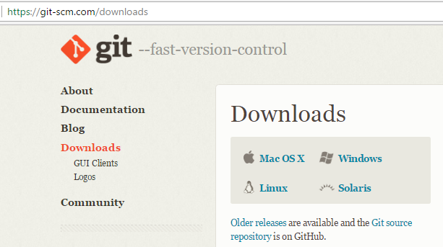

Sign up in GIT HUB <https://github.com/>

Create a new repository in Git Hub

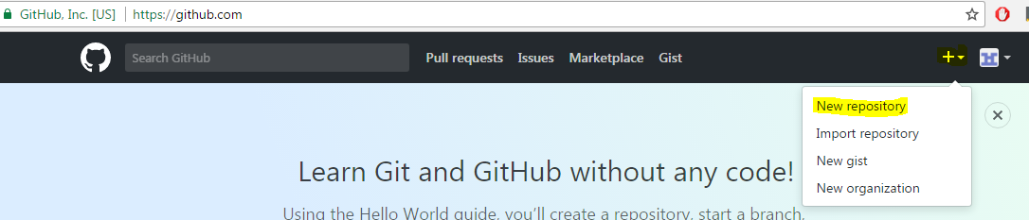

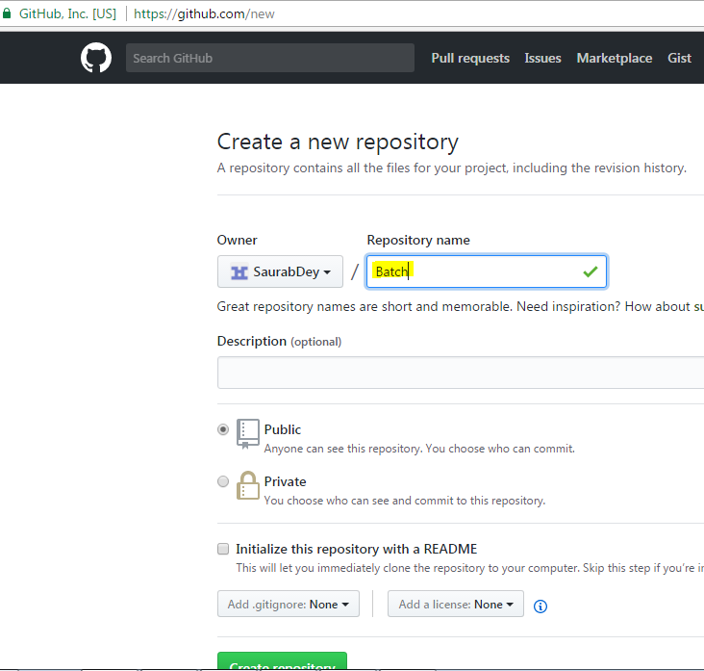

***--------GIT LOCAL---------***

Go to the directory you want to save in GIT HUB e.g. D:\GITrepository

Right Click on the directory and you will be able to see GIT BASH and GIT GUI (*If Git is installed in your machine)*

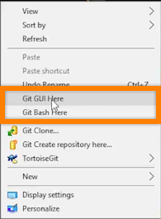

Check present working directory

* pwd

Change present working directory

* cd .. (cd space ..)

Change directory

* cd D:
* cd D:/GitRepository

***Config changes***

* git config - - global user.name ”Your Name”
* git config - - global user.email “Your Email ID”

Check the config values

* git config user.email

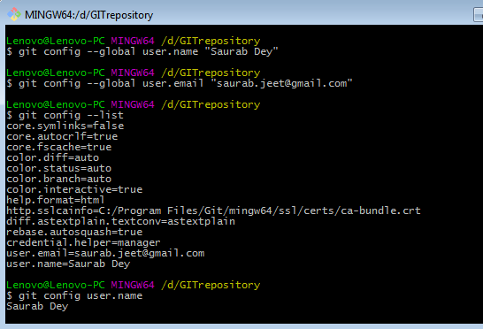

Need more information or help

* git help
* git help commit

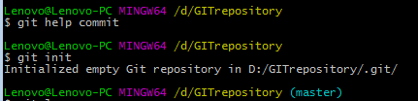

***--------GIT LOCAL to GIT HUB---------***

***Make the directory as a Git Repository***

* git init

List everything in the project

* ls
* ls -la (hidden files which handles GIT)

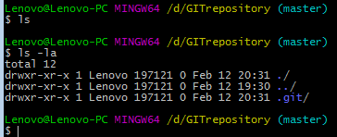

***Add and Commit in GIT***

Note: Copy or Add a file in the directory

* git status- Checks the stage where the file is located in
* Different stages are Working Copy-> Local Staging -> Local Repository
* Working Copy to Local Staging phase
  + - git add . (where ‘.’ adds everything in the directory )

or

* + - git add filename.txt
* Local Staging to Local Repository
  + - git commit -m “This is my First Commit”

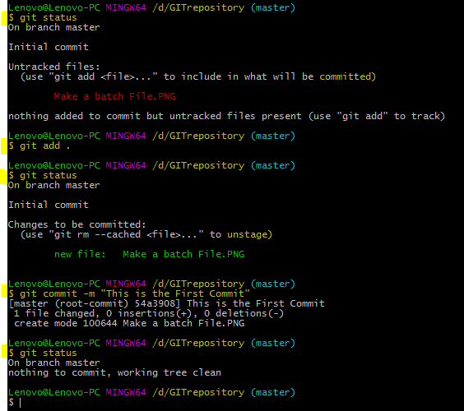

***Local Repository to GIT Hub***

* Set ‘origin’ which consist of GIT Hub’s repository’s URL

As per the screenshot

* + - git remote add origin git@github.com:SaurabDey/Batch9.git

or

* + - git remote add origin https://github.com/SaurabDey/Batch9.git

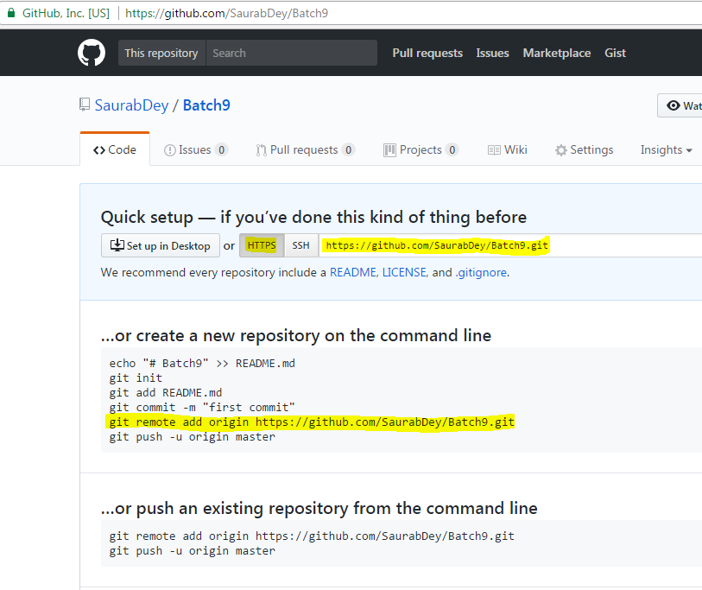

* Push Local Repository to GIT Hub
  + - git push origin master

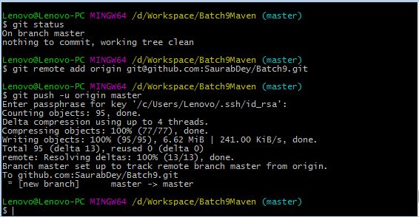

After the code is pushed you can check the Project is available in GIT HUB

